HTML Assignment 3: HTML Table of Definitions
Include at least 12 most common/helpful HTML tags (therefore at least 13 rows including table header). These tags should not be deprecated HTML tags such as <center> or formatting tags such as <b> (for which you should use CSS instead).

Tag | Definition | Example
<title></title> | Title of document that appears on the browser tab (in <head> only) | See browser title above "Assignment 3"
<p> </p> | Paragraph | This is a paragraph
<img src="link" alt="pic" style="5%"> | Image | 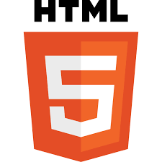
<hr> | Creates a horizontal line on the page | _____________________
<!--…--> | Comment, it won’t show up on the web page | ***The comment is in NotePad
<html> </html> | The whole HTML document | This is an HTML document  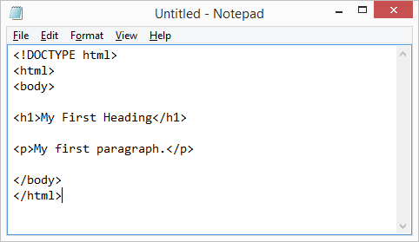
<h1> </h1> | First-level heading large text | This is an h1 text
<head> </head> | The head, or prologue of the HTML document | This code contains a head  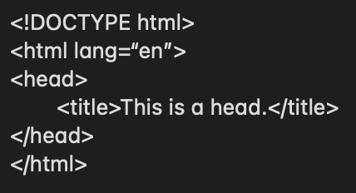
<a href= “link”>…</a> | Link | This is a link to gov.bc
<button> </button> | It is used to represent a clickable button | This is a button, if you click on it, it will say hello.  (Button)
<ol> </ol> | Ordered list | This is an ordered list  1. Mathematics  2. Computer Science  3. English  4. Physical Education
<ul> </ul> | Unordered list | This is an unorder list  • Mathematics  • Computer Science  • English  • Physical Education
<li> </li> | List item | ***Please refer to the list items in ordered list and unordered list
<span> </span> | Give a group of text different styling | This is a spanned text
<tr> </tr> | Define a row in an HTML table | ***Every row in this document

